

CS-250: Lab 05
Implementation of General Trees

Muhammad Mujtaba
CMD ID: 540040
mmujtaba.bese25seecs@seecs.edu.pk

  - Class: BESE 16B
  - Batch: 2k25

Tree DS Used:
See tree.hpp and tree.cpp
GitHub Repo Link: https://github.com/mmujtaba25/CS-250
Zip File for only Lab 05: https://github.com/mmujtaba25/CS-250/releases/tag/lab-05

Task 1:
See tree.cpp#L28 and task1.cpp.
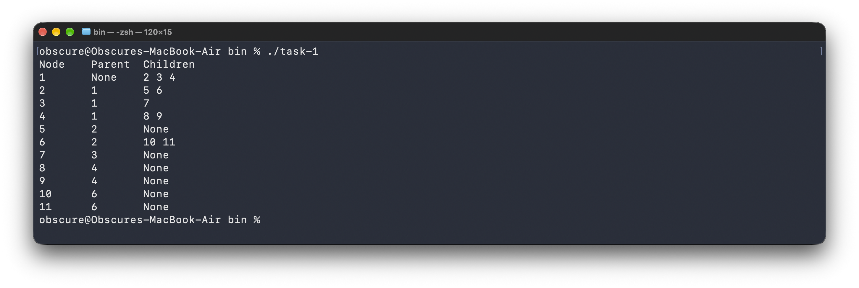

Task 2:
See tree.cpp#L47 and task2.cpp.
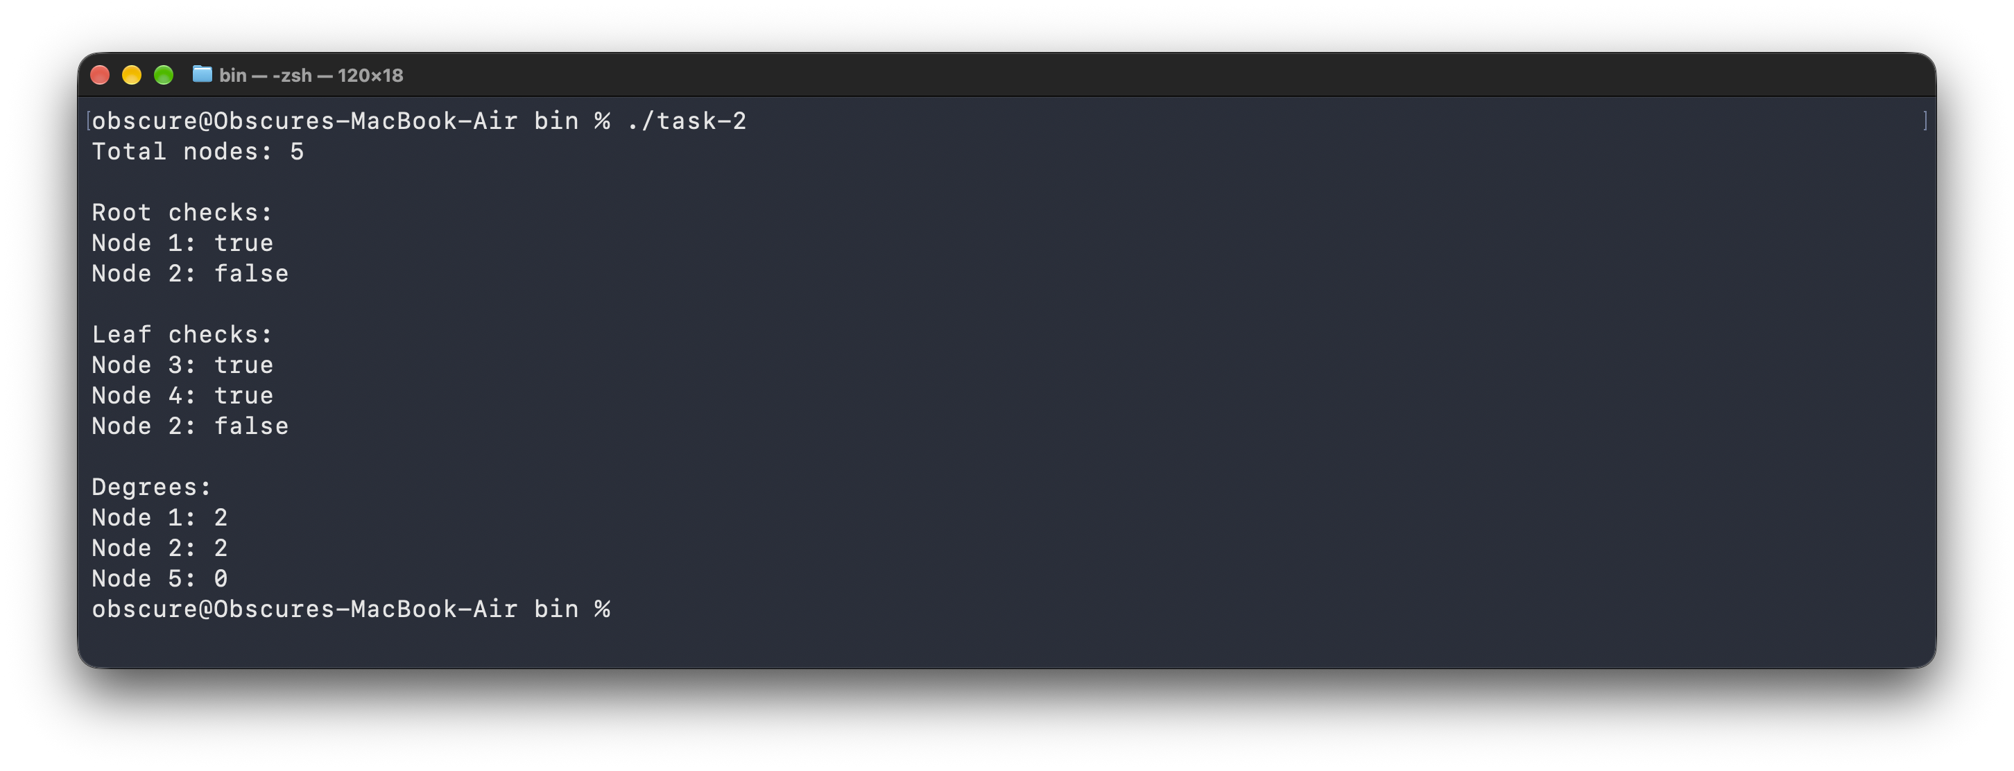

Task 3:
See tree.cpp#L95, tree.cpp#L119 and task3.cpp.
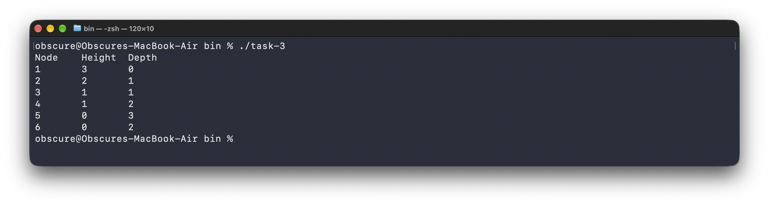

Task 4:
See tree.cpp#L136 and task4.cpp.
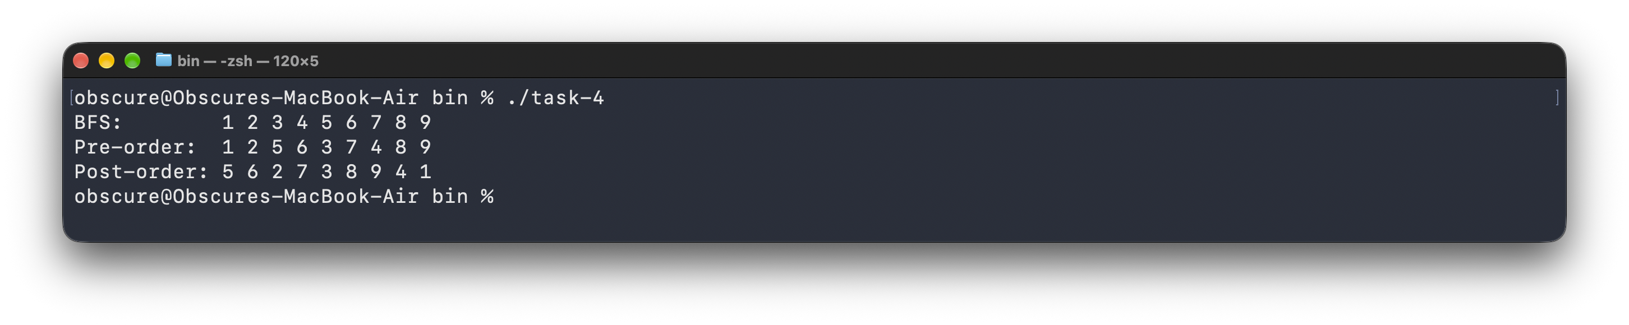

Task 5:
See tree.cpp#L204 and task5.cpp.
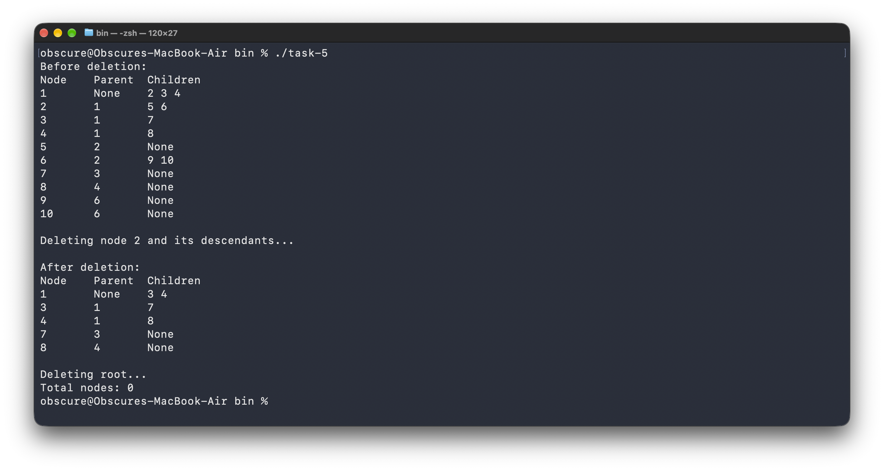

Task 6:
See task6.cpp.
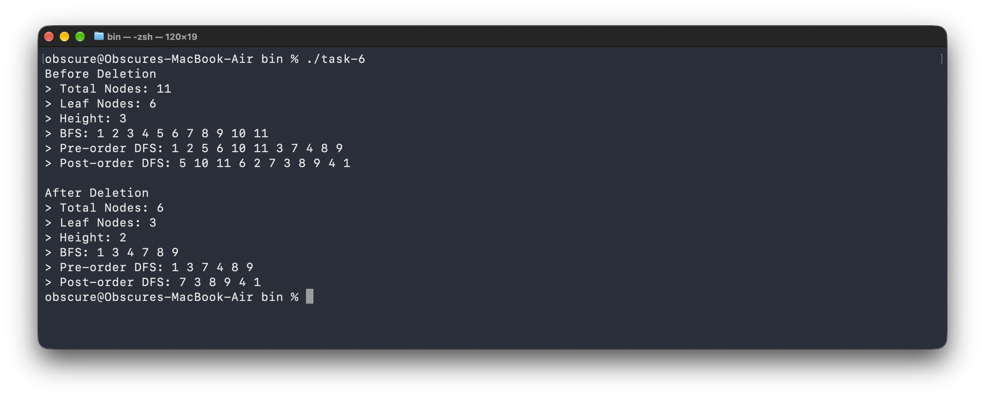
Time Complexity:
O(N) for all traversals, since each node visited only once.

